Project Proposal

On

**Online Airlines Ticket Booking Management System**



Rija Khatri

00175069

Computing Project

Level 5 in Computing

Softwarica College of IT and E-Commerce

Kathmandu, Nepal

04/01/2019

Submitted to: Niman Maharzan

# Contents

1. INTRODUCTION 4

1.1 Justification of Project 4

1.2 Problem Statement 4

1.3 Description of Project 5

1.3.1 Features of System 5

2. Project Scope 6

2.1 Scope and Limitations 6

2.2 Aims and Objective 6

3.Development Methodology 6

3.1 Methodology used 6

3.2 Design Pattern 7

3.3 System Architecture 8

4. Work Breakdown Structure (WBS) / Scheduling 9

4.1 Work Breakdown Structure 9

4.2 Milestones 10

5. Risk Management 13

6. Configuration Management 14

7. Conclusion of the project 14

8.References………………………………………………………………………………………………………………………………….15

**List of figures**

Figure 1: Waterfall Model …………………………………………...5

Figure 2: Model View Controller ……………………………………………6

Figure 3: 3-Tiers Structure ………………………………………………7

Figure 4: WBS Structure ………………………………………………8

Figure 5: Days division for Tasks ………………………………………………11

Figure 6: Gantt Chart of Online Movies Booking System …………………………………………12

Figure 7: MBS on GitHub …………………………………………14

Figure 8: Tree Structure of MBS …………………………………………15

# 

# 1. INTRODUCTION

**Project Introduction**

Technology has affects human lives in many ways. People are becoming more advanced and technology based day by day. Directly or indirectly people are affected by technology from the moment they wake up, all day long and through the night. It clearly shows how deeply technology is interwoven with our lives. They do not want to lose their time by standing on long queue or arguing with the shopkeepers. The proposed project “Airlines Ticket Booking Management System” whereby customer can book tickets from their home 24/7hrs from a airlines booking app in real time.

## 1.1 Justification of Project

**Background of Project**

Online Airlines Ticket Booking system is web portal where people can book their tickets from their home which is accessible 24/7. It provides attractive offers especially discounts to the customer. They can book tickets for specific date and choose timing for their required destinations. They can check price for the ticket also. First of all, they need to register in the app and login to browser so that they will be notify about all the tickets prices and upcoming offers and discounts in online airlines booking system. There will be ease in cancellation of tickets for customers.

Online Airlines Ticket Booking Management System is fully customized and immediate generation of PNR or vouchers. It is user-friendly application. It provides airline or cruise line travel reservation services issues electronic paper ticket which simply means has become more popular in. In my project, I have used PHP for programming and MySQL for managing database of airlines.

## 1.2 Problem Statement

Many problems will encounter while booking ticket like one should go booking counter to book ticket and stand in queues for long time. The current system in booking counter might be outdated or expired and difficult to apply. People might not get tickets for seats as per their desire or it might be uncomfortable for them to travel and people should go for booing counter to know airbus information, flight information and cancellation of tickets.

The proposed system will overcome this entire problem. It helps people by providing current price of tickets, flight timing, airbus information, flight information, sudden cancellation, weather information etc. it provides as interface to schedule flights and reservations for an airline that services.

## 1.3 Description of Project

### 1.3.1 Features of System

The features of proposed system are:-

* User can register and login to the system

User can easily register to the system by filling up registration form and login to the system simply by providing their valid username and password.

* User can book tickets from home

User can book tickets from home without standing in a long queue. They can book tickets as per their wish and also check availability of seats in which they feel comfortable to travel.

* User can book online tickets

If they buy airline ticket online in time, it will be cheaper for them.

* Hotels and transportation booking

User can easily book hotel and transportation through our system also so that they will not have to face any kind of problems during their journey.

* User can search flight

User can search flight for their required destination and book tickets by comparing different tickets price also.

## 1.4 Overview of Project

My project is about Online Airlines Ticket Booking Management System. It is a web portal where people can book their seats and tickets 24/7 anywhere anytime. It facilitates people in many ways like booking tickets from their home without standing in a long queue, other facilities like booking hotel and transportations also.

# 2. Project Scope

## 2.1 Scope and Limitations

**Scope**

Online airlines ticket booking system provides an interface to schedule flights and reservations for an airline that services. The main responsibility of this system is to keep track of system users, customers, airbus information, flight information and cancellation. It stores all the information in database like price of ticket, departure time, destinations etc which can easily retrieve by users.

**Limitations**

Online Ticket Booking Management system requires internet access. Customer will have to have access to the internet. User don’t believe the promises of free online booking system as there are many fake online websites which has cheated many people by showing offers and discounts.

## 2.2 Aims and Objective

The main aim of my project is to provide quality services to the people while buying online airlines ticket 24/7 anytime anywhere. It also helps reduce human resources and promote ticketing system in internet also. It helps to provide detailed information about airlines ticket to the system.

The main objectives of online ticket booking system is to be able to solve the issues in the existing system regarding to the accuracy, usability, efficiency, effectiveness, speed and user-friendliness. It manage all the information related to flights, departure time, ticket price etc. Its main objective is to reduce human resources and focus more on customer satisfaction also. It will increase profit for particular organization also. People can also save on travel agent fees by purchasing online tickets, instead of contacting a travel agent.

# 3. Development Methodology

## 3.1 Methodology used

I have used waterfall approach for this project. As waterfall model is the first methodology used in the software development. It illustrates the software development process in a linear sequential flow. It is the first model which is widely used in software engineering to ensure success of the project. In waterfall model, the whole process of software development is divided into separate phases, the outcome of one phase acts s the input for the next phase sequentially. The sequential phases in waterfall model are requirement gathering and analysis, system design, implementation, testing, deployment of system and maintenance.

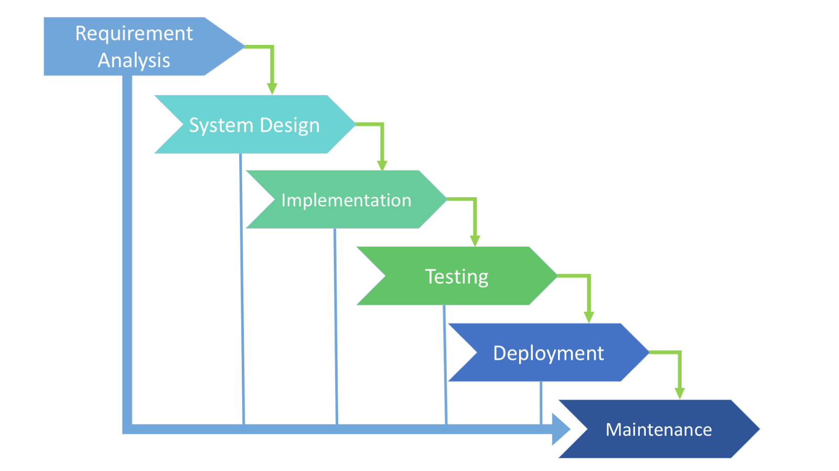

Fig.1:- Waterfall model

First of all, all possible requirements of the system to be developed are captured in the requirement gathering and analyzing phase. The requirement specifications from first phase are studied in the system design phase and it is prepared. It helps in specifying hardware and system requirements. With inputs from the system design, the system is first developed in small programs called units which are integrated in implementation phase. All the units developed in the implementation phase are integrated into a system after testing for each unit. Once the functional and non-functional testing is done, the product is deployed in the customer environment or released into the market. There are some issues which come up in the client environment. To fix those issues, patches are released. Maintenance is done to deliver these changes in the customer environment.

## 3.2 Design Pattern

A software design pattern is a general, reusable solution to a commonly occurring problem within a given context in software development.

I am using MVC (Model View Controller) design pattern in this project as MVC pattern is used to separate application’s concerns. It specifies that an application consist of a data model, presentation information and control information. It is a framework which is used on both desktop and web-based application.

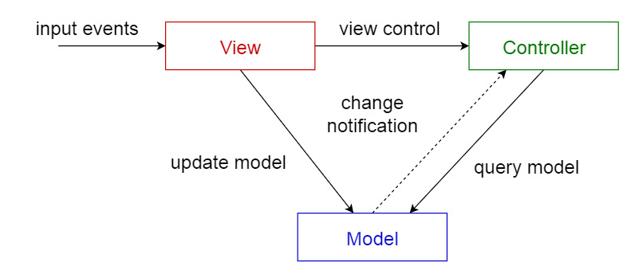

Fig.2: - MVC Design Pattern

Model: - model represents an object carrying data. It can also have logic to update controller if its data changes.

View: - view represents the visualization of the data and handles all UI logic of application.

Controller: - it acts as both model and view and controls the data flow in model objects and updates the view whenever data changes.

## 3.3 System Architecture

System architecture is the type of architecture which defines the representation of whole layer. It is the conceptual model that defines the structure, behavior and view of system. For my project, I have use 3 tier structure which includes presentation tier, logic tier and data tier. I have use 3 tier structures because the presentation layer (user interface) helps to translate tasks and result to something the user can understand. Logic tier co-ordinates the application, processes commands, makes logical decisions and performs calculations. Data tier stores and retrieves the information from a database or file system.

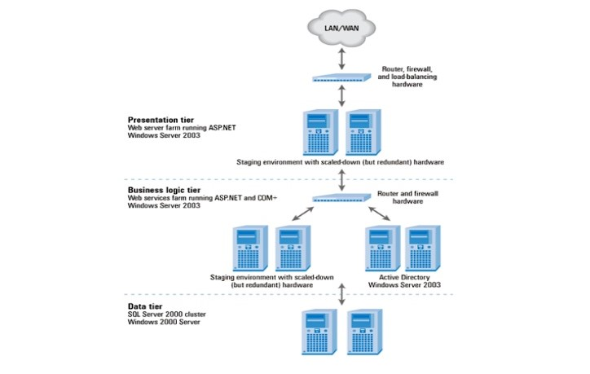

Fig.3:- 3 tier architecture

# 4. Work Breakdown Structure (WBS) / Scheduling

## 4.1 Work Breakdown Structure

Work breakdown structure is process of breakdown of a project into smaller components. A work breakdown structure is a type of project deliverable that organizes the team’s work into convenient system.

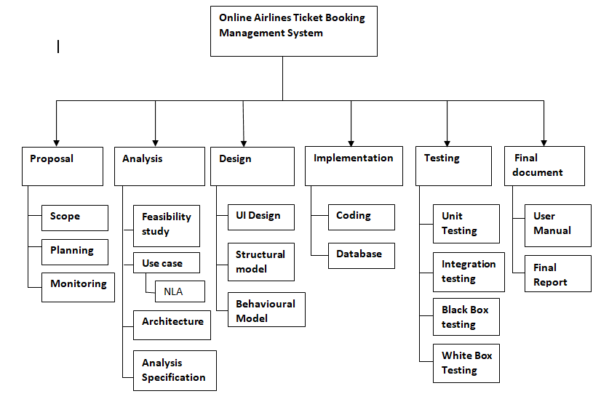

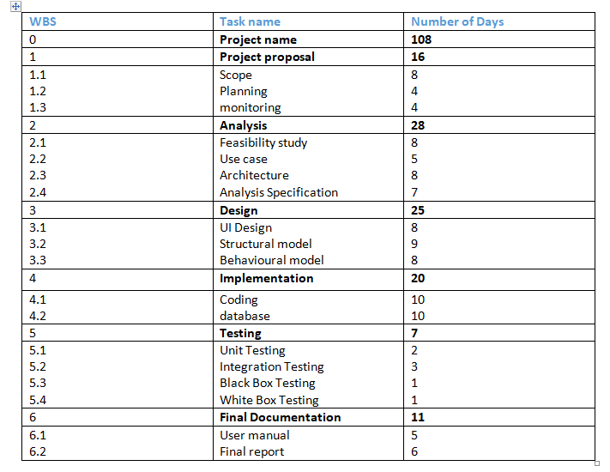

## Fig.4:- WBS Structure

## 4.2 Milestones

|  |  |  |  |  |
| --- | --- | --- | --- | --- |
| s.no | Title | start date | End date | No. of days |
| 1 | Proposal | 25/03/19 | 09/04/19 | 16 |
| 2 | Analysis | 10/04/19 | 07/05/19 | 28 |
| 3 | Design | 08/05/19 | 01/06/19 | 25 |
| 4 | Implementation | 02/06/19 | 21/06/19 | 20 |
| 5 | Testing | 22/06/19 | 28/06/19 | 7 |
| 6 | Final Date | 29/06/19 | 09/07/19 | 11 |

Fig.5:-days division for task

**Description of Milestones**

**Project Management**

**Proposal**

I have assigned total 16 days for this proposal which means 4days for planning, 8 days for scope and 4days for monitoring in order to provide proper overview of the project.

**Analysis**

I have assigned total 28 days for the analysis which means 8days for feasibility, 5 days for use case, 8 days for architecture and 7days for analysis specification. This phase requires proper information about project so I have distributed more number of days for the analysis part.

**Design**

Once the requirements are finalized, system design is perform. So, I have assigned total 25 days for the design which means 8days for UI design, 9 days for structural model and 8days for behavioral model.

**Implementation**

After the verification of the design of the system, implementation part is performed. So, I have assigned total 20 days for the implementation which means 10days for coding and 10days for database.

**Testing**

After setting up the system, testing is done in order to know whether the system functions correctly or not. So, I have assigned total 7 days for the testing which means 2days for unit testing, 3 days for integration testing, 1 day for black box testing and 1day for white box testing.

**Final Documentation**

I have distributed total 11 days for the final documentation which means 5days for user manual and 6days for final report in order to check whether there is any error or not.

**4.3 Scheduling / Gantt Chart**

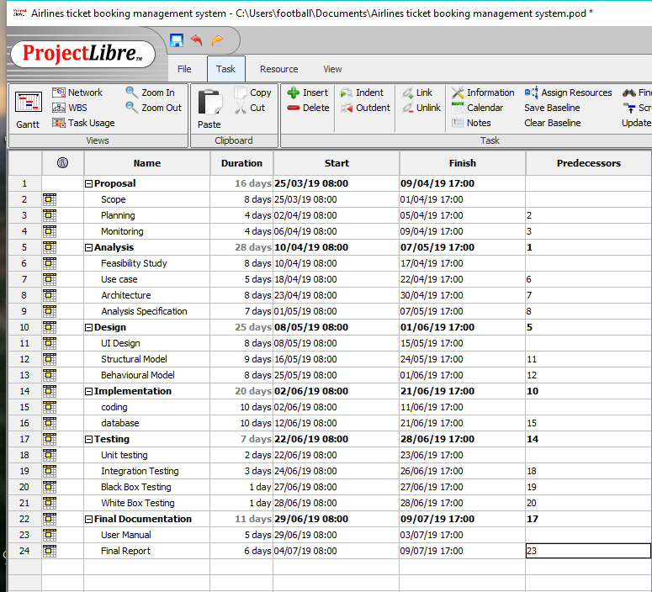

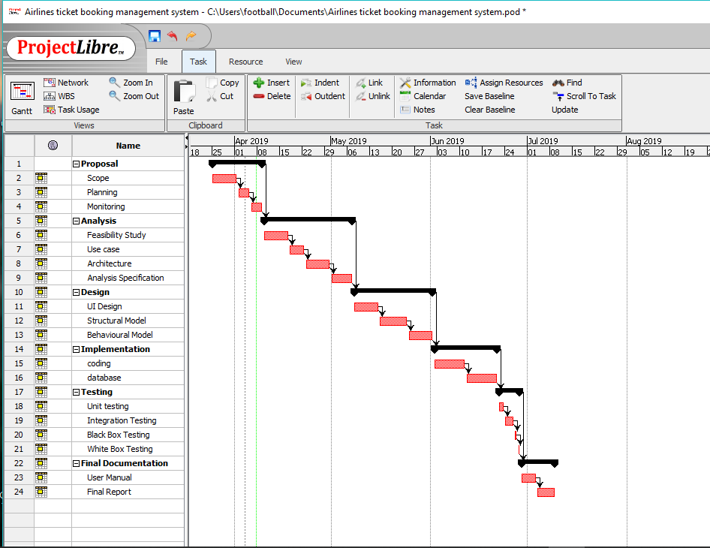 Fig.6:- Gantt chart of Online Airlines Ticket Booking Management System

# 5. Risk Management

Risk management is the identification, evaluation, analyzing and prioritizing of risk factor in project. It is the process of figuring out risk in the project and managing them. Acceptance, avoidance, exploitation, reduction, transference are the method to control risk in project management.

**Impact = Likelihood * Consequence**

Risk likelihood and consequences are shown below:-

|  |  |
| --- | --- |
| Likelihood | Values |
| low | 1 |
| medium | 2 |
| high | 3 |

Fig: - Risk likelihood

|  |  |
| --- | --- |
| Consequences | Values |
| Very low | 1 |
| low | 2 |
| Medium | 3 |
| High | 4 |
| Very high | 5 |

Risk consequences values are shown below: -

|  |  |  |  |  |  |
| --- | --- | --- | --- | --- | --- |
| S.No. | Risks | Likelihood | Consequences | Impact | Solution |
| 1 | Lack of skill | 3 | 3 | 9 | Provide training to the employees |
| 2 | Natural disaster | 1 | 5 | 5 | Backup should be maintain |
| 3 | Wrong time estimation | 2 | 3 | 6 | Proper planning must be done |
| 4 | Changing requirement | 2 | 4 | 8 | Proper planning should be done |
| 5 | Hard disk crash | 2 | 4 | 8 | Data backup |
| 6 | Server failure | 1 | 4 | 4 | Online data backup |
| 7 | Lack of cost | 2 | 4 | 8 | Estimation of cost should be done |

# 6. Configuration Management

It is the process for establishing and maintaining consistency of a product’s performance, functional and physical attributes with its requirements, design and operational information throughout its life. It handles changes to a system in a way that it maintains integrity over time. It helps to track hardware, software and related information to the system. It also manages, organize and control changes in the documents, codes and other entities during the **SDLC (software development life cycle**).

# 7. Conclusion of the project

Online Airline Ticket Booking Management System is a web portal where people can book their tickets and seat 24/7 anywhere anytime. It provides many facilities to the people, by providing domestic and international ticket booking services at the cheap price, possible discounts, flight time, search destinations, pay with a flexible payment options along with 24hrs support for any ticketing related issues.

I have used waterfall model and MVC design pattern for this project. Proper scheduling and suitable breakdown are also done.

# 7. References

<https://www.slideshare.net/guestd0cc01/3-tier-architecture>

<https://www.google.com.np/search?biw=1366&bih=654&tbm=isch&sa=1&ei=SaOqXLj0NcjerQHM_IfoBQ&q=waterfall+model+definition&oq=waterfall+model+def&gs_l=img.1.0.0j0i8i30j0i24l4.774572.776902..778348...0.0..0.401.2667.0j2j5j2j1......1....1..gws-wiz-img.......35i39j0i5i30.5hXfwSW3AeY#imgrc=aoMkCX5oxr_3XM>:

<https://www.google.com.np/search?q=MVC+design+pattern+figures&tbm=isch&source=iu&ictx=1&fir=16eXmhZ4nlfJEM%253A%252Ce8UVBtvM3o1qgM%252C_&vet=1&usg=AI4_-kRfL-G2CVercADBw4oJYWKuuB6PKQ&sa=X&ved=2ahUKEwjMteOFvbvhAhWIfn0KHfwCCNgQ9QEwDnoECAkQCg#imgrc=3NlA8u7FDG5_gM:&vet=1>